Benha University  Faculty of Engineering at Shoubra  Electrical Engineering Department |  | Microwave fundamentals  3rd Year Communications  (2013-2014)

Sheet 2 (2 weeks)

$\boxed{1}$ A lossless transmission line is terminated with a 100 Ω load. If the SWR on the line is 1.5, find the two possible values for the characteristic impedance of the line.
$\boxed{2}$ Let Z_{sc} be the input impedance of a length of coaxial line when one end is short-circuited and let Z_{oc} be the input impedance of the line when one end is open-circuited. Derive an expression for the characteristic impedance of the cable in terms of Z_{sc} and Z_{oc}.
$\boxed{3}$ A 100 Ω transmission line has an effective dielectric constant of 1.65. Find the shortest open-circuited length of this line that appears at its input as a capacitor of 5 pF at 2.5 GHz. Repeat for an inductance of 5 nH.
$\boxed{4}$ A radio transmitter is connected to an antenna having an impedance 80 + j40 Ω with a 50 Ω coaxial cable. If the 50 Ω transmitter can deliver 30 W when connected to a 50 Ω load, how much power is delivered to the antenna?
$\boxed{5}$ The transmission line circuit shown below has V_{g}= 15 V rms, Z_{g}=75 Ω, Z_{o} =75 Ω, Z_{L}= 60- j40Ω, and $l$ = 0.7λ. Compute the power delivered to the load using three different techniques:
- find Γ and compute
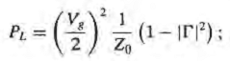
- find Z_{in} and compute
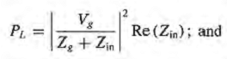
- find V_{L} and compute
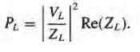
- Discuss the rationale for each of these methods. Which of these methods can be used if the line is not lossless?
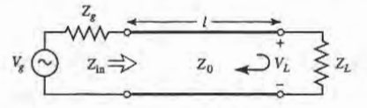
$\boxed{6}$ For a purely reactive load impedance of the form Z_{L}= jX, show that the reflection coefficient magnitude lf I Γ I is always unity. Assume the characteristic impedance Z_{o} is real.
$\boxed{7}$ Consider the transmission line circuit shown below. Compute the incident power, the reflected power, and the power transmitted into the infinite 75 Ω line. Show that power conservation is satisfied.
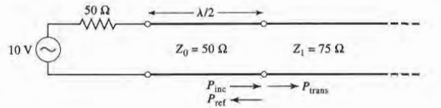
$\boxed{8}$ A generator is connected to a transmission line as shown below. Find the voltage as a function of z along the transmission line. Plot the magnitude of this voltage for
$-l$ $≤$ Z $≤$ 0
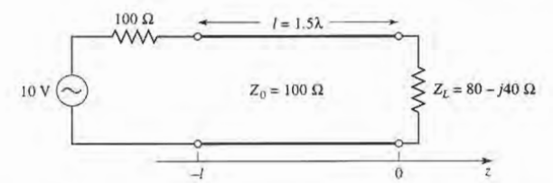
Good Luck
Dr. Gehan Sami

